Name ____________________________________________________Period____________________

Current Event Report -- DUE:

- (2 pts.) Title of article:______________________________________________________________
- (2 pts.) Date of article: _____________________________________________________________
- (2 pts.) Where did you find this article: ________________________________________________
- (4 pts.) Who/What is your article talking about: _________________________________________
- (3 pts.) Where are the events in your article happening? Label the city/country where your article takes place on the map below:

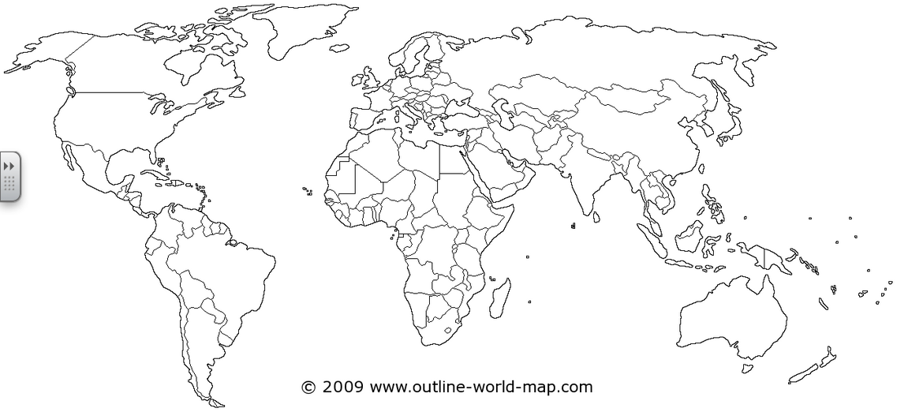
3, 2, 1

(6 pts.) Three things about what is happening in your article.
1.

2.

3.
(4 pts.) Two interesting details from your article.
1.

2
(5 pts.) One thought-provoking question to orally quiz the class. (BE SURE TO INCLUDE THE ANSWER TO YOUR QUESTION)
QUESTION:

ANSWER:

SUMMARY (2 pts.) Summary: By reading this, I learned

(5 pts.) PLEASE ATTACH HIGHLIGHTED NEWS ARTICLE TO THIS FORM!!!

